**Overview:**

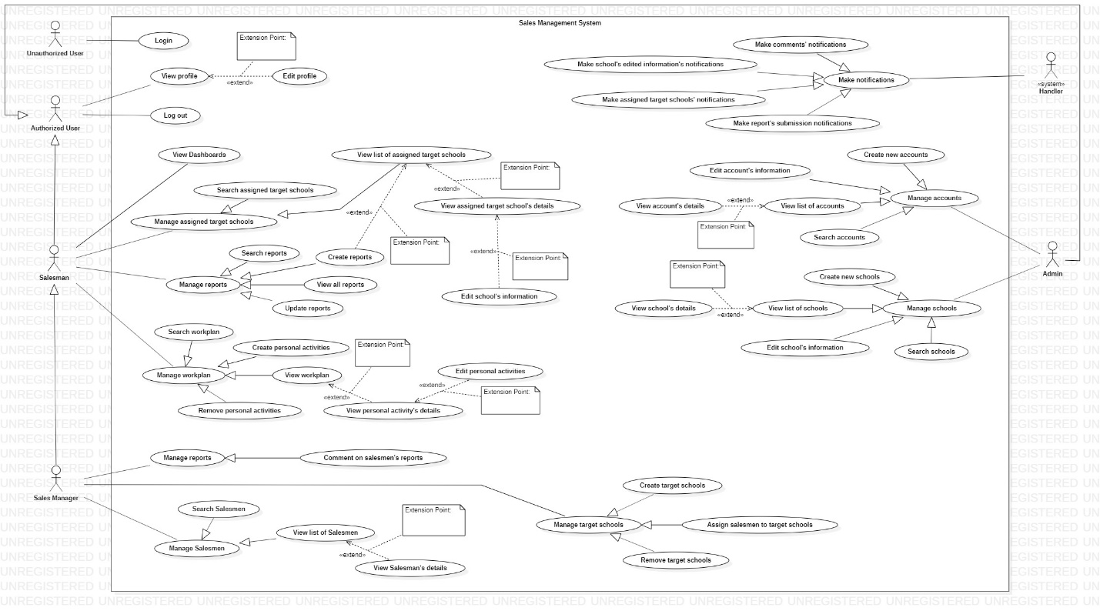

1. **<<Unauthorized user>> Login:**

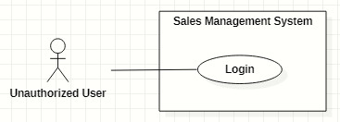

**<<Authorized user>> Overview:**

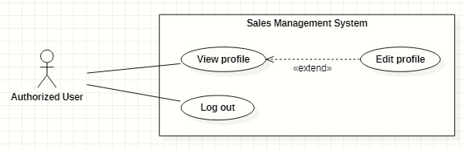

1. **<<Authorized user>> View profile:**

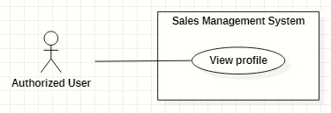

1. **<<Authorized user>> Edit profile:**

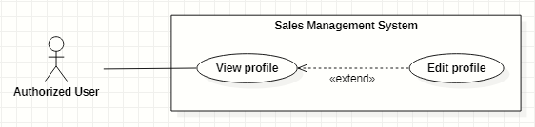

1. **<<Authorized user>> Logout:**

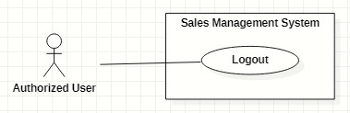

**<<System Handler>> Overview:**

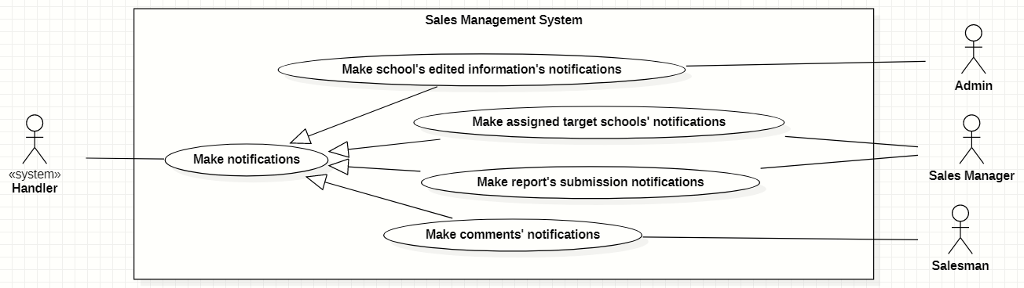

1. **<<System Handler>> Make assigned target schools’ notifications:**

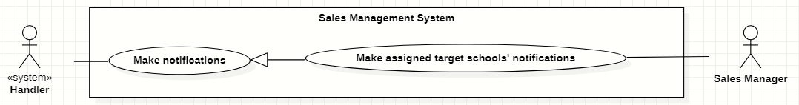

1. **<<System Handler>> Make comments’ notifications:**

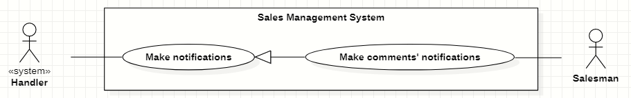

1. **<<System Handler>> Make school’s edited information’s notifications:**

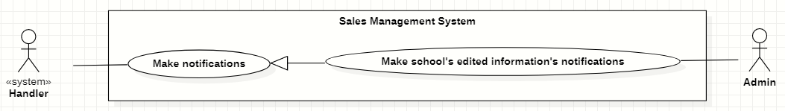

1. **<<System Handler>> Make report’s submission notifications:**

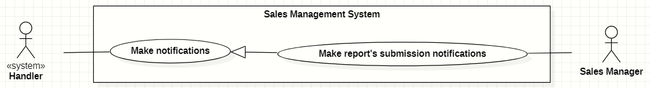

**<<Admin>> Overview:**

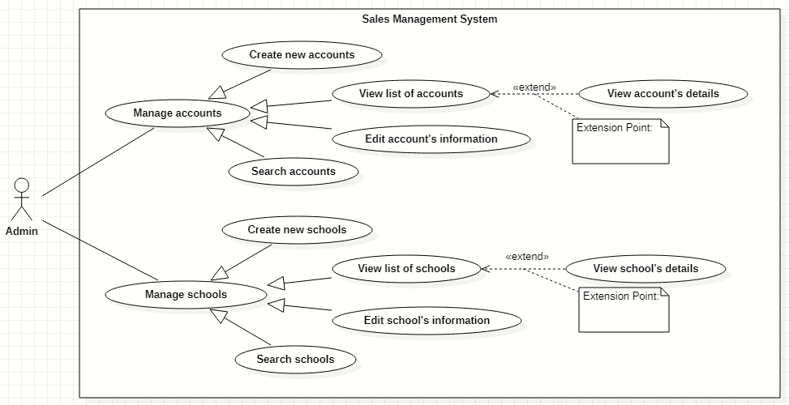

1. **<<Admin>> Create new accounts:**

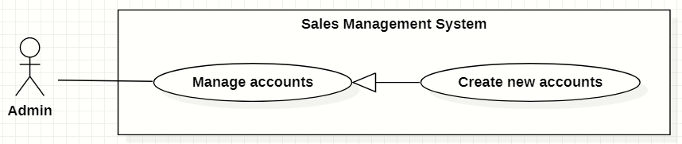

1. **<<Admin>> View list of accounts:**

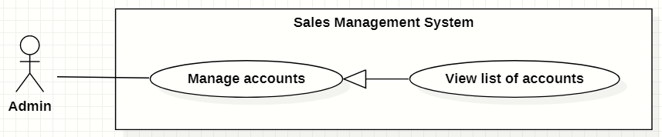

1. **<<Admin>> View account’s details:**

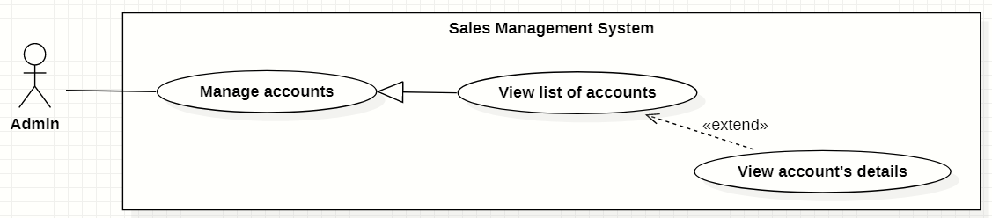

1. **<<Admin>> Edit account’s information:**

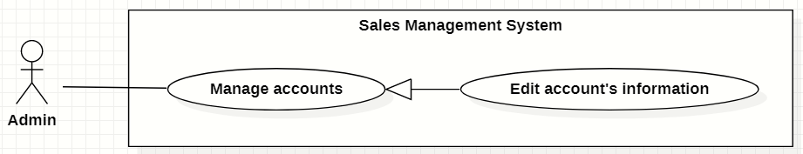

1. **<<Admin>> Search accounts:**

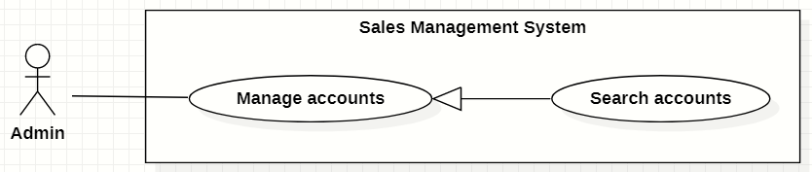

1. **<<Admin>> Create new schools:**

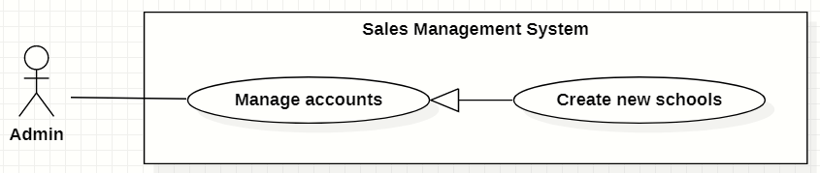

1. **<<Admin>> View list of schools:**

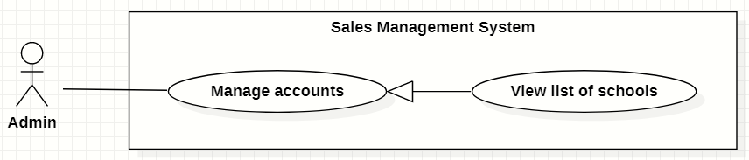

1. **<<Admin>> View school’s details:**

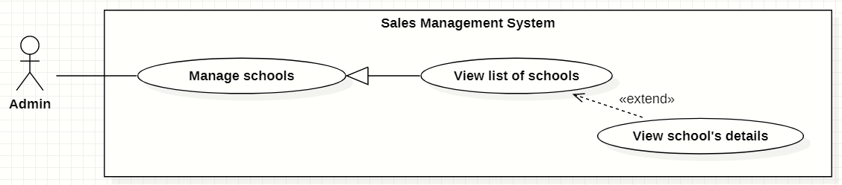

1. **<<Admin>> Edit school’s information:**

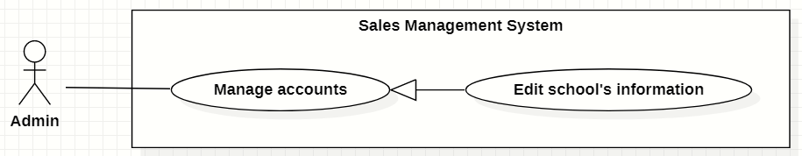

1. **<<Admin>> Search schools:**

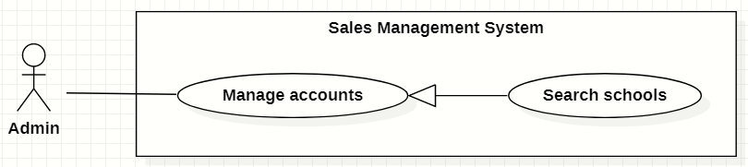

**<<Salesman>> Overview:**

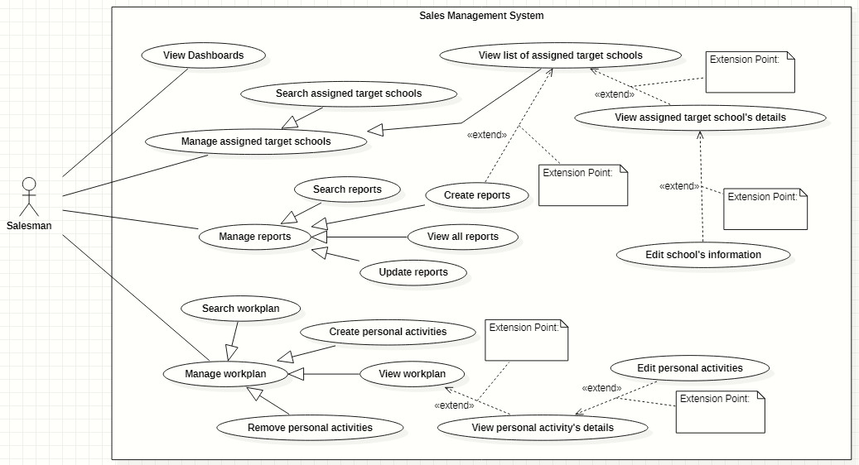

1. **<<Salesman>> View dashboards:**

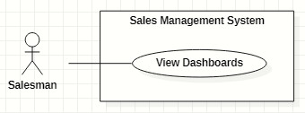

1. **<<Salesman>> Search assigned target schools:**

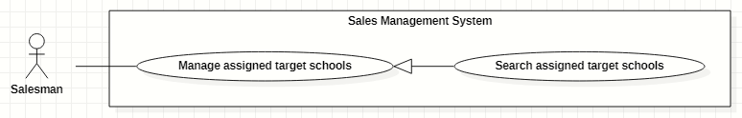

1. **<<Salesman>> View list of assigned target schools:**

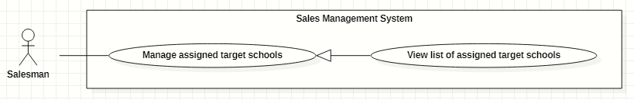

1. **<<Salesman>> View assigned target school's details:**

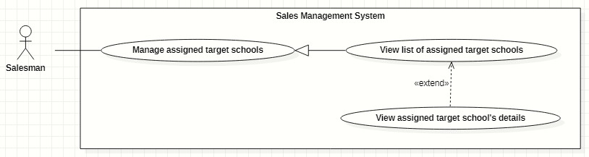

1. **<<Salesman>> Edit school's information:**

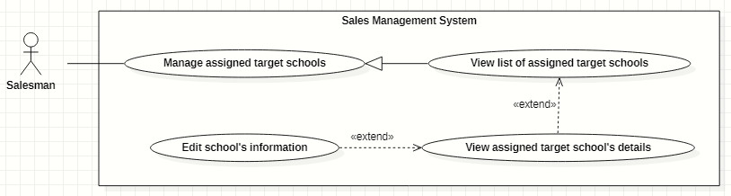

1. **<<Salesman>> Create reports:**

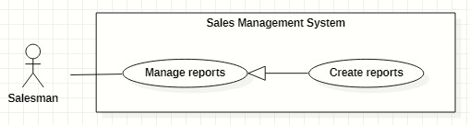

1. **<<Salesman>> View all reports:**

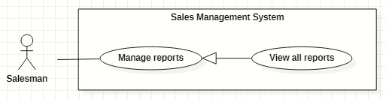

1. **<<Salesman>> Search reports:**

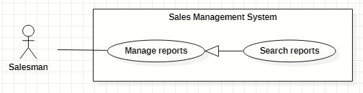

1. **<<Salesman>> Update reports:**

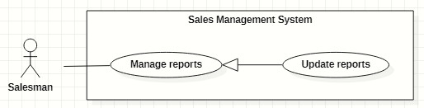

1. **<<Salesman>> Create personal activities:**

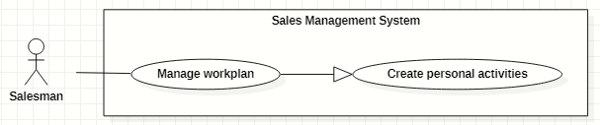

1. **<<Salesman>> View workplan:**

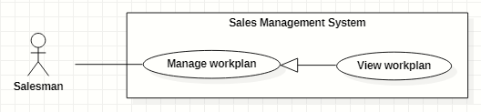

1. **<<Salesman>> Search workplan:**

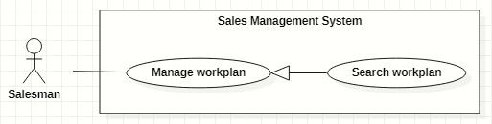

1. **<<Salesman>> View personal activity's details:**

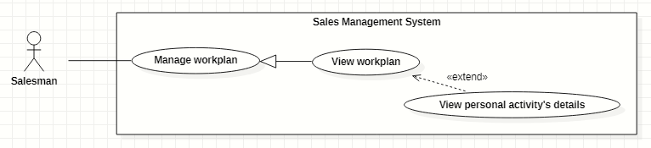

1. **<<Salesman>> Edit personal activities:**

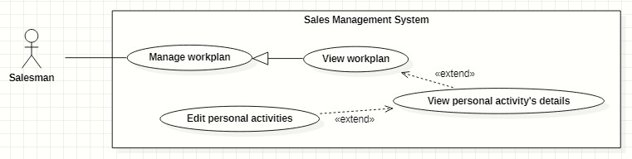

1. **<<Salesman>> Remove personal actitivities:**

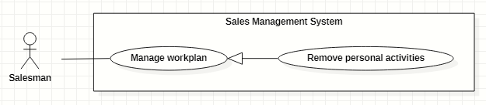

**<<Sales Manager>> Overview:**

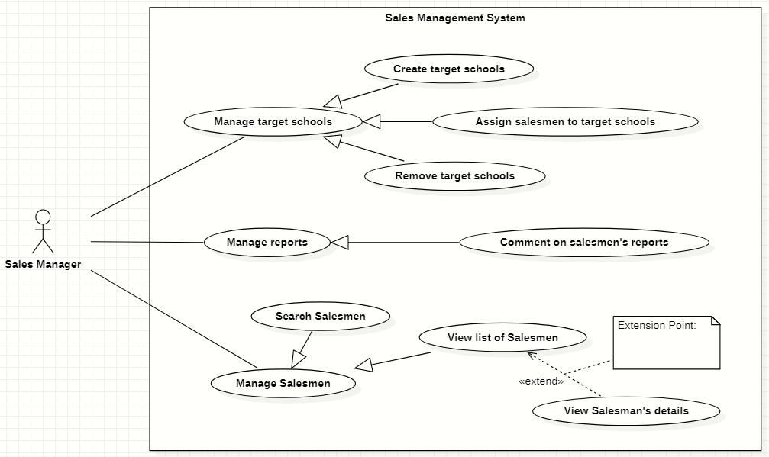

1. **<<Sales Manager>> Comment on salesmen's reports:**

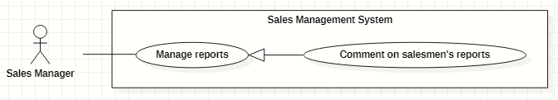

1. **<<Sales Manager>> Create target schools:**

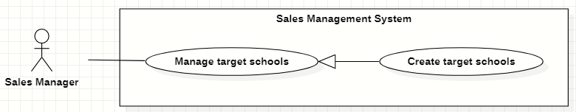

1. **<<Sales Manager>> Assign salesmen to target schools:**

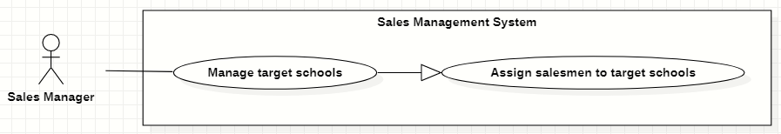

1. **<<Sales Manager>> Remove target schools:**

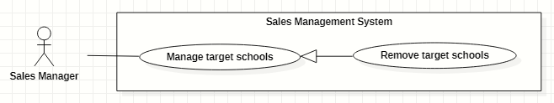

1. **<<Sales Manager>> Search salesmen:**

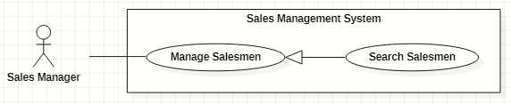

1. **<<Sales Manager>> View list of salesmen:**

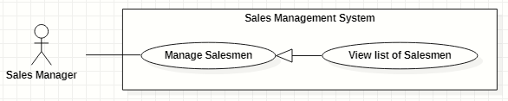

1. **<<Sales Manager>> View salesman's details:**

